

v1.0

06-September-2022

USER MANUAL

AWS CFT TEMPLATE GSLB

# PATENT PROTECTION

A10 Networks, Inc. products are protected by patents in the U.S. and elsewhere. The following website is provided to satisfy the virtual patent marking provisions of various jurisdictions including the virtual patent marking provisions of the America Invents Act. A10 Networks, Inc. products, including all Thunder Series products, are protected by one or more of U.S. patents and patents pending listed at: a10-virtual-patent-marking.

# TRADEMARKS

A10 Networks, Inc. trademarks are listed at: a10-trademarks.

# CONFIDENTIALITY

This document contains confidential materials proprietary to A10 Networks, Inc. This document and information and ideas herein may not be disclosed, copied, reproduced, or distributed to anyone outside A10 Networks, Inc. without prior written consent of A10 Networks, Inc.

# DISCLAIMER

This document does not create any express or implied warranty about A10 Networks, Inc. or about its products or services, including but not limited to fitness for a particular use and non-infringement. A10 Networks, Inc. has made reasonable efforts to verify that the information contained herein is accurate, but A10 Networks, Inc. assumes no responsibility for its use. All information is provided "as-is." The product specifications and features described in this publication are based on the latest information available; however, specifications are subject to change without notice, and certain features may not be available upon initial product release. Contact A10 Networks, Inc. for current information regarding its products or services. A10 Networks, Inc. products and services are subject to A10 Networks, Inc. standard terms and conditions.

# ENVIRONMENTAL CONSIDERATIONS

Some electronic components may possibly contain dangerous substances. For information on specific component types, please contact the manufacturer of that component. Always consult local authorities for regulations regarding proper disposal of electronic components in your area.

# FURTHER INFORMATION

For additional information about A10 products, terms and conditions of delivery, and pricing, contact your nearest A10 Networks, Inc. location, which can be found by visiting [www.a10networks.com](http://www.a10networks.com/).

Contents

[PATENT PROTECTION 1](#_Toc122537637)

[TRADEMARKS 1](#_Toc122537638)

[CONFIDENTIALITY 1](#_Toc122537639)

[DISCLAIMER 1](#_Toc122537640)

[ENVIRONMENTAL CONSIDERATIONS 1](#_Toc122537641)

[FURTHER INFORMATION 2](#_Toc122537642)

[Introduction to Installing vThunder on AWS 5](#_Toc122537643)

[Overview of AWS 5](#_Toc122537644)

[Aws Terminology 6](#_Toc122537645)

[CloudFormation Template – GSLB 7](#_Toc122537646)

[Overview 7](#_Toc122537647)

[Prerequisites 7](#_Toc122537648)

[AWS Account & Subscription. 7](#_Toc122537649)

[AWS Account and Environment Setup to Run CFT Template [One Time Step] 8](#_Toc122537650)

[AWS key-pairs to access ec2 instances. 10](#_Toc122537651)

[Steps to create a SSH key [Optional] 10](#_Toc122537652)

[System Requirements 11](#_Toc122537653)

[Chapter 1 – Install vADC 14](#_Toc122537654)

[Install 14](#_Toc122537655)

[Chapter 2 - GSLB configuration Setup 20](#_Toc122537656)

[Configure 20](#_Toc122537657)

[Install 21](#_Toc122537658)

[Sites and Controller Complete Configurations: 21](#_Toc122537659)

[Verify 31](#_Toc122537660)

[Chapter 3 – Let us Verify 31](#_Toc122537661)

[Login to vThunder 31](#_Toc122537662)

[GSLB Group 31](#_Toc122537663)

[GSLB Protocol 33](#_Toc122537664)

[DNS lookup 34](#_Toc122537665)

# Introduction to Installing vThunder on AWS

vThunder for Amazon Web Services is a fully operational, software-only version of the ACOS Series Server Load Balancer (SLB), or Application Delivery Controller (ADC) device. It is configurable by ACOS CLI, GUI, AXAPI, and Harmony Controller. For more information see Virtual Instances in Harmony Controller.

vThunder is a virtual appliance, yet it retains most of the functionality available on the hard- ware based ACOS appliances. Managing vThunder is the same as managing hardware based ACOS device, and vThunder has the same CLI configurations and GUI presentation.

The networking configuration for vThunder is also like hardware based ACOS devices.

A10 Networks brings Out-Of-Box template to deploy vThunder along with multiple features and functionality with pre-defined format into amazon cloud.

Please refer below section for more details.

* Three Network Card Interface (3NIC).
* TLS/SSL Certification (SSL).
* Server Load Balancer (SLB)

# Overview of AWS

Amazon Web Services offers a broad set of global cloud-based products including compute, storage, databases, analytics, networking, mobile, developer tools, management tools, IoT, security, and enterprise applications: on-demand, available in seconds, with pay-as-you-go pricing. From data warehousing to deployment tools, directories to content delivery, over 200 AWS services are available. New services can be provisioned quickly, without the upfront fixed expense.

AWS uses the following tools to create and manage resources:

**AWS Portal** - A web console to create and monitor AWS resources. For more information: https://aws.amazon.com/console/

**AWS CLI—** The AWS CLI enables you to start running commands that implement functionality equivalent to that provided by the browser-based AWS Management Console from the command prompt in your terminal program:

* **Linux shells** – Use common shell programs such as [bash](https://www.gnu.org/software/bash/), [zsh](http://www.zsh.org/" \t "_blank), and [tcsh](https://www.tcsh.org/" \t "_blank) to run commands in Linux or macOS.
* **Windows command line** – On Windows, run commands at the Windows command prompt or in PowerShell.
* **Remotely** – Run commands on Amazon Elastic Compute Cloud (Amazon EC2) instances through a remote terminal program such as PuTTY or SSH, or with AWS Systems Manager. For more information: http//docs.aws.amazon.com/cli/index.html?nc2=h\_ql\_doc\_cli

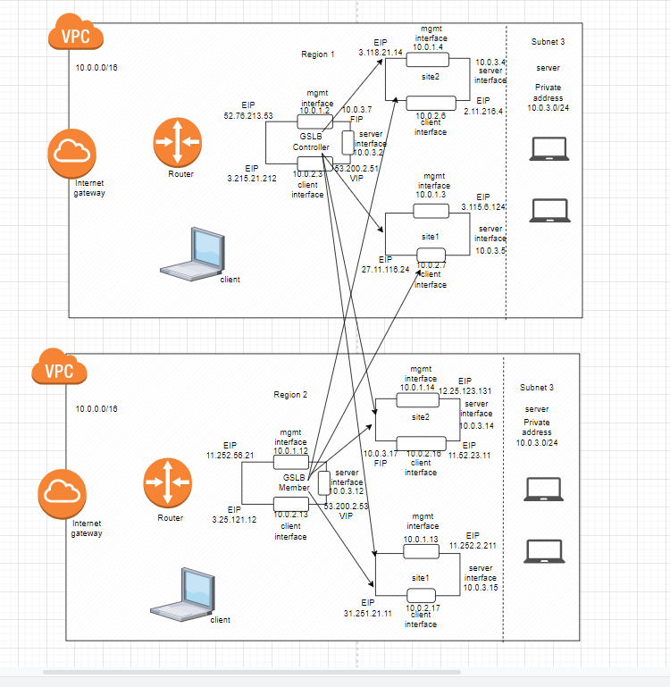

# Aws Terminology

**Access control list (ACL):** A firewall/security layer on the subnet level. For more information https://docs.aws.amazon.com/AmazonS3/latest/userguide/acls.html

**CloudWatch:** Service that allows you to monitor various elements of your AWS account. For more information: https://docs.aws.amazon.com/cloudwatch/index.html

**Elastic Compute Cloud (EC2):** A virtual computer, very similar to a desktop/laptop computer. For more information: https://docs.aws.amazon.com/AWSEC2/latest/UserGuide/concepts.html

**Lambda:** Serverless computing that will replace EC2 instances, for the most part. For more information: https://docs.aws.amazon.com/lambda/latest/dg/welcome.html

**Security group (SG):** Firewall/security layer on the server/instance level. For more information https://docs.aws.amazon.com/AWSEC2/latest/UserGuide/ec2-security-groups.html

**Subnet:** A subsection of a network and generally includes all the computers in a specific location. For more information: https://docs.aws.amazon.com/AWSCloudFormation/latest/UserGuide/aws-resource-ec2-subnet.html

**Virtual Private Cloud (VPC):** A private subsection of AWS you control and in which you can place AWS resources. For more information: https://docs.aws.amazon.com/vpc/latest/userguide/what-is-amazon-vpc.html

# CloudFormation Template – GSLB

## Overview

CloudFormation template to create resource in 2 regions, 1 GSLB controller and 2 site devices in each region instances on AWS portal.

## Prerequisites

### AWS Account & Subscription.

Generate access\_key\_id and secret\_access\_key if you don’t have it. For more details visit:

<https://docs.aws.amazon.com/powershell/latest/userguide/pstools-appendix-sign-up.html>

### AWS Account and Environment Setup to Run CFT Template [One Time Step]

1. Download and install python setup using following link:

<https://www.python.org/ftp/python/3.8.5/python-3.8.5-amd64.exe>

1. To verify that Python is available on our local machine, we need to open the command line (in Windows search, type cmd and press Enter to open Command Prompt or right-click on the Start button and select Windows Command Prompt), type python, and press Enter.
2. If Python is properly installed, we will see a notification like the one below:

*Python 3.8.x (tags/v3.10.2:a58ebcc, Jan 17 2022, 14:12:15) [MSC v.1929 64 bit (AMD64)] on win32 Type "help," "copyright," "credits," or "license" for more information.*

1. To check if PIP is already installed on Windows, we should open the command line again, type pip, and press Enter.
2. If PIP is installed, we will receive a long notification explaining the program usage, all the available commands and options. Otherwise, if PIP is not installed, the output will be:

*'pip' is not recognized as an internal or external command, operable program or batch file.*

1. To install pip on window visit:

[https://pip.pypa.io/en/stable/installation](https://pip.pypa.io/en/stable/installation/)

1. Install all dependencies go to current working directory and use following command:

pip install -r requirements.txt

1. Locate and open /credentials in current working directory.
2. Change the access key as well as secret access key as per your aws account.

*Copy credentials file to C:\Users\<USERNAME>\.aws*

1. Locate and open /config in current working directory.
2. Change aws region details.

1. Copy AWS config file on your local system, located at:

*C:\Users\<USERNAME>\.aws*

**For linux, macOS, Unix**:

1. Locate and open /credentials.
2. Change the access key as well as secret access key as per your aws account.

*Copy credentials file to ~/.aws*

1. Locate and open /config
2. Change aws region details.

1. Copy AWS config file on your local system, located at:

*~/.aws*

For more information: https://docs.aws.amazon.com/sdk-for-java/v1/developer-guide/setup-credentials.html

### AWS key-pairs to access ec2 instances.

## Steps to create a SSH key [Optional]

Note: You can use existing key pair if you have already created.

1. Go to the EC2 dashboard and click on key pairs.

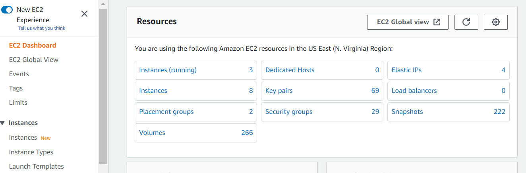

1. Now click on create key pair at the top right.



1. Now name the key and select the key pair type as RSA and key file format as .pem.

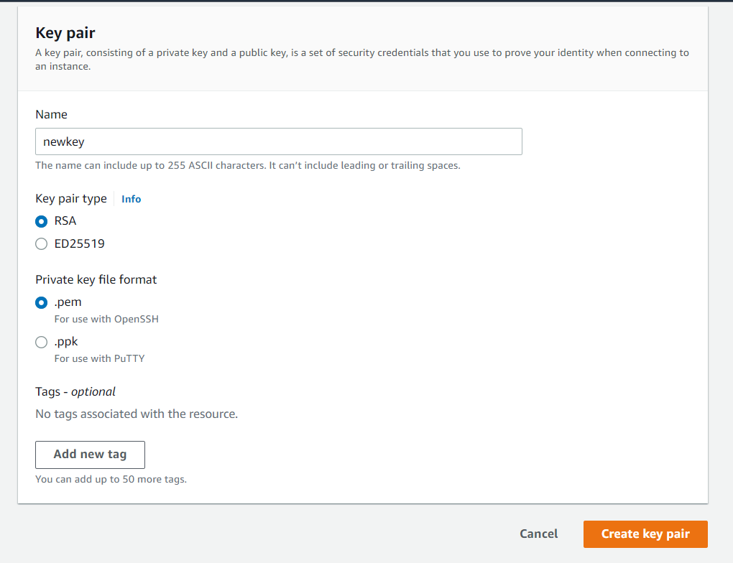

## System Requirements

Below all AWS cloud resources will be created.

All templates come with default value it can be change while execution.

**Stack**

A new stack is created with the specified name in each region location.

**Interfaces**

Three interfaces (1 Management, 2 Data) for 3 vThunder will be created in each GSLB region. Address prefix can be configured in parameter file.

Default names:

|  |
| --- |
| *<vth>-inst1-mgmt-nic1* |
| *<vth>-inst1-data-nic1* |
| *<vth>-inst1-data-nic2* |
| *<vth>-inst2-mgmt-nic1* |
| *<vth>-inst2-data-nic1*  *<vth>-inst2-data-nic2* |
| *<vth>-inst3-mgmt-nic1* |
| *<vth>-inst3-data-nic1* |
| *<vth>-inst3-data-nic2* |

**Subnets**

Three subnets will be created in each GSLB region. Address prefix can be configured in parameter file.

Default names:

*<vth>-vpc-mgmt-sub1*

*<vth>-vpc-data-sub1*

*<vth>-vpc-data-sub2*

**Virtual Private Network**

A virtual Private network will be created. Address prefix is 10.0.0.0/16.

Default name*:* {stack-name} *-vpc*

**Elastic Public Ip**

Elastic Public Ip will be created and attached to management and data interface of vThunder instances.

Default name:

*<vth> -inst1-mgmt-nic1-ip*

*<vth>-inst1-data1-nic1-ip*

*<vth>-inst2-mgmt-nic1-ip*

*<vth>-inst2-data1-nic1-ip*

*<vth>-inst3-mgmt-nic1-ip*

*<vth>-inst3-data1-nic1-ip*

**Security Group**

For each A10 device, the management, client-side data interface and server-side data interface have security group assigned with Allow permissions for relevant ports.

Two security groups will be created 1 for management and another for client-side data interface and server-side data interface.

Default name:

Path: *Stacks>> vth>> Resources>> vThunderSecurityGroup*

Note: If you want to add new rule to security group then select security group and then edit inbound rule and add rule and save.

Path: EC2>> Security Groups>> {stack-Name}-mgmt/data>> Edit inbound rules

1. <vth>*-sg-mgmt*

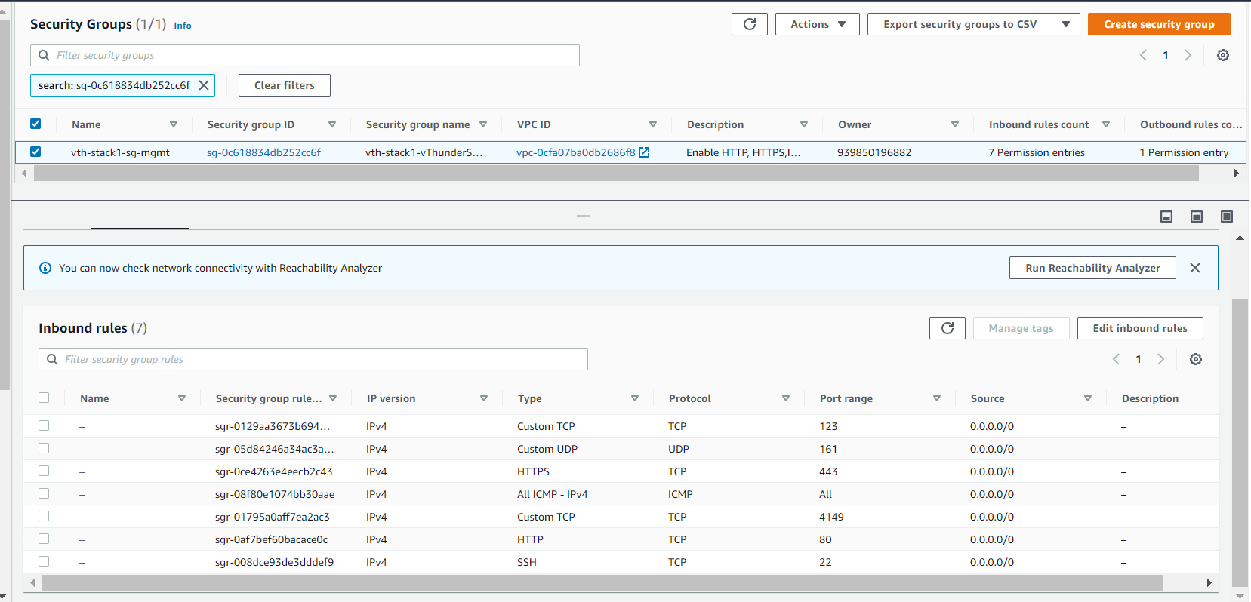

2. <vth> *-sg-data*

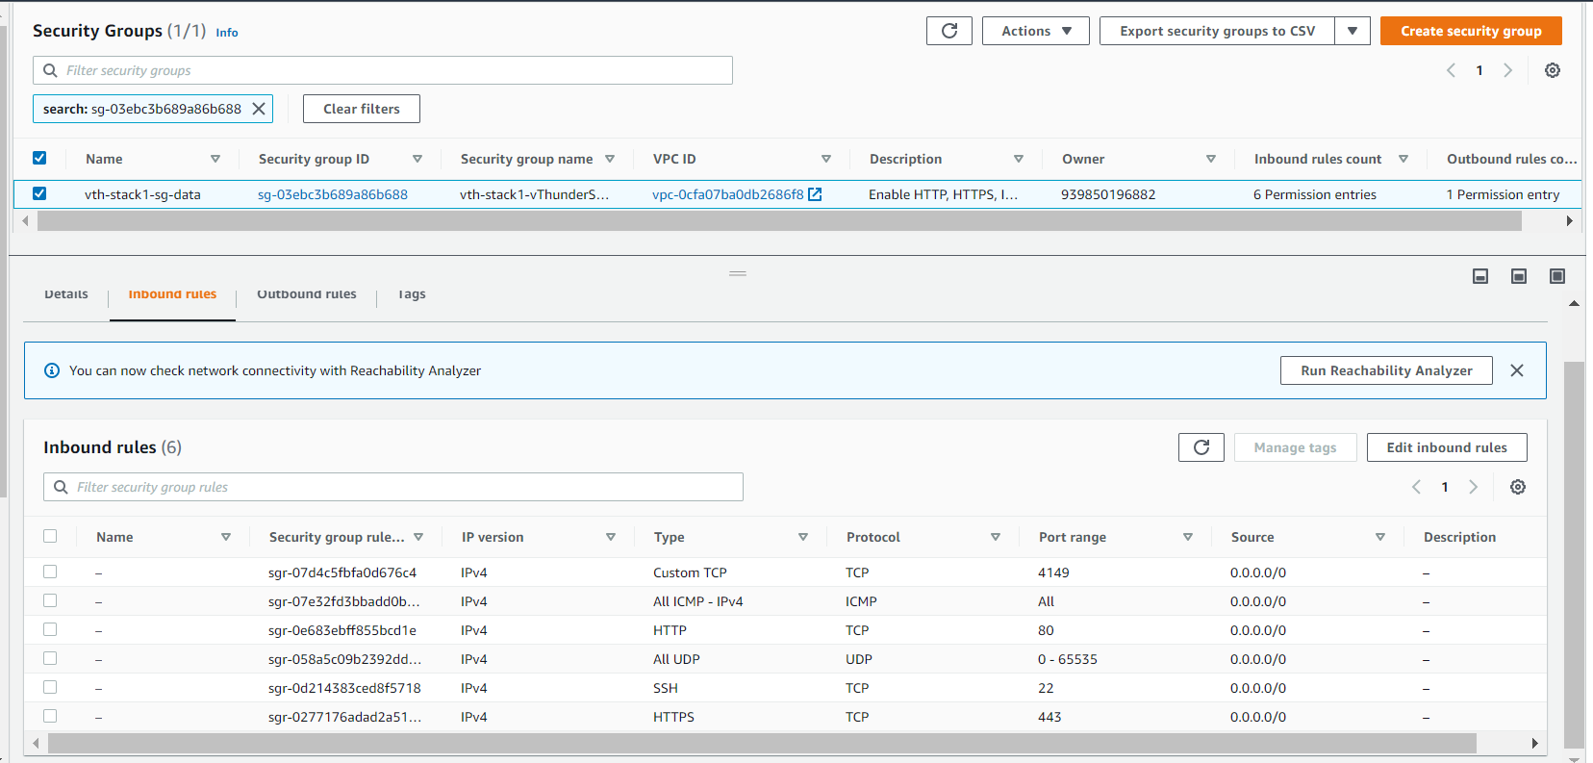

**vThunder Instance**

In each gslb region 3 vThunder EC2 instance will be created.

**Default Size**: m4.xlarge (40 Gb memory)

**Default name**:

$vmName+$region1 <vth> *-controller-region1*

$vmName+$region1 <vth>*-site1-region1*

$vmName+$region1 <vth>*-site2-region1*

$vmName+$region2 <vth>*-controller-region2*

$vmName+$region2 <vth>*-site1-region2*

$vmName+$region2 <vth>*-site2-region2*

# Chapter 1 – Install vADC

All resources will get created in AWS.

## Install

1. Navigate to AWS Console -> CloudFormation -> Stacks -> Create Stack
2. User can select any region from dropdown for GSLB region1.

1. Select prepare template.
2. Click on upload a template file. Upload the CFT\_TMPL\_GSLB\_Region\_1. json file and click on next.

Two CFT templates for each GSLB region.

1. CFT\_TMPL\_3NIC-6VM-2RG-GSLB\_REGION\_1.json
2. CFT\_TMPL\_3NIC-6VM-2RG-GSLB\_REGION\_2.json
3. Go to next.
4. Provide stack name. For example: <vth>
5. Provide availability zone. For example: us-east-1a
6. Provide tagValue. For example: <a10-vthunder-adc>
7. Confirm default values.

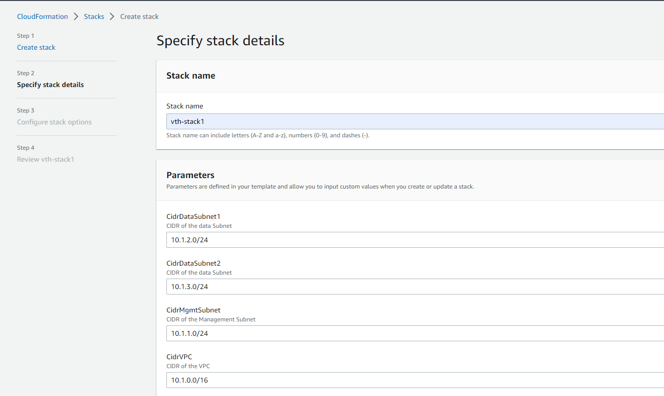

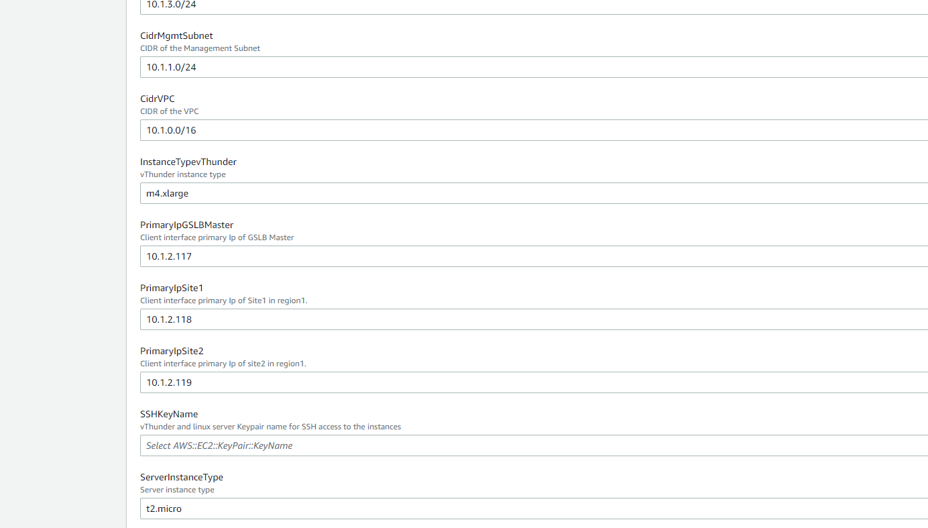

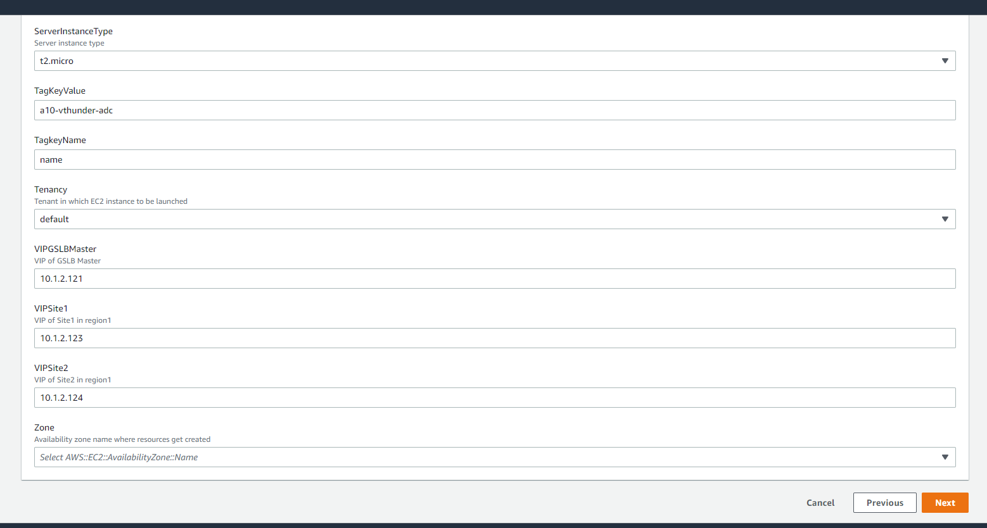

NOTE : If you change the IP addresses other than default make sure they come under CIDR range of Data Subnet1 (i.e 10.1.2.0/24 is default CIDR of region1 and 10.2.2.0/24 is default CIDR of region2)

1. Below listed sizes are verified for vThunder.

|  |  |  |  |
| --- | --- | --- | --- |
| **Instance** | **vCPU** | **Memory** | **Number of Network Interfaces** |
| c4.xlarge | 4 | 7680 | 4 |
| c4.4xlarge | 16 | 30720 | 8 |
| c4.8xlarge | 36 | 61440 | 8 |
| d2.xlarge | 4 | 31232 | 4 |
| d2.2xlarge | 8 | 62464 | 4 |
| d2.4xlarge | 16 | 124928 | 8 |
| d2.8xlarge | 36 | 249856 | 8 |
| m4.xlarge | 4 | 16384 | 4 |
| m4.2xlarge | 8 | 32768 | 4 |
| m4.4xlarge | 16 | 65536 | 8 |
| m4.10xlarge | 40 | 163840 | 8 |
| i2.xlarge | 4 | 31232 | 4 |
| i2.2xlarge | 8 | 62464 | 4 |
| i2.4xlarge | 16 | 124928 | 8 |
| i2.8xlarge | 32 | 249856 | 8 |
| c5d.large | 2 | 4096 | 3 |
| c5d.9xlarge | 36 | 73728 | 8 |
| c5d.2xlarge | 8 | 32768 | 4 |
| c5d.4xlarge | 16 | 73728 | 8 |
| c5.xlarge | 4 | 8192 | 4 |
| c5.2xlarge | 8 | 16384 | 4 |
| c5.4xlarge | 16 | 32768 | 8 |
| c5.9xlarge | 36 | 73728 | 8 |
| g3.4xlarge | 16 | 124928 | 8 |
| g3.8xlarge | 32 | 249856 | 8 |
| i3.large | 2 | 15616 | 3 |
| i3.xlarge | 4 | 31232 | 4 |
| i3.2xlarge | 8 | 62464 | 4 |
| i3.4xlarge | 16 | 124928 | 8 |
| i3.8xlarge | 32 | 249856 | 8 |
| m5d.large | 2 | 8192 | 3 |
| m5d.xlarge | 4 | 16384 | 4 |
| m5d.2xlarge | 8 | 32768 | 4 |
| m5d.4xlarge | 16 | 65536 | 8 |
| m5.large | 2 | 8192 | 3 |
| m5.xlarge | 4 | 16384 | 4 |
| m5.2xlarge | 8 | 32768 | 4 |
| m5.4xlarge | 16 | 65536 | 8 |
| r5d.large | 2 | 16384 | 3 |
| r5d.xlarge | 4 | 32768 | 4 |
| r5d.2xlarge | 8 | 65536 | 4 |
| r5d.4xlarge | 16 | 131072 | 8 |
| r5.large | 2 | 16384 | 3 |
| r5.xlarge | 4 | 32768 | 4 |
| r5.2xlarge | 8 | 65536 | 4 |
| r5.4xlarge | 16 | 131072 | 8 |
| r4.large | 2 | 15616 | 3 |
| r4.xlarge | 4 | 31232 | 4 |
| r4.2xlarge | 8 | 62464 | 4 |
| r4.4xlarge | 16 | 124928 | 8 |
| r4.8xlarge | 32 | 249856 | 8 |
| t3.medium | 2 | 4096 | 3 |
| t3.large | 2 | 8192 | 3 |
| t3.xlarge | 4 | 16384 | 4 |
| t3.2xlarge | 8 | 32768 | 4 |
| z1d.large | 2 | 16384 | 3 |
| z1d.xlarge | 4 | 32768 | 4 |
| z1d.2xlarge | 8 | 65536 | 4 |
| z1d.3xlarge | 12 | 98304 | 8 |
| z1d.6xlarge | 24 | 196608 | 8 |

**Note**: Follow these steps again after changing to the different GSLB region to deploy it.

11) Remain others as default.

12) Go to next.

13) Review

14) Submit

***Set Back and Relax, it will take maximum 10 mins. 😊***

1. Go to AWS Console -> *CloudFormation-> Stacks-> {stack name}*

15) Verify all above resources created.

1. ***Verify status check of vThunder instance we created.***
2. EC2>> *Instances>><vth>-controller-region-1*
3. Open any browser and type http://<vthunder\_public\_IP>
4. Enter username – admin
5. Enter Password – {ec2 instance id}

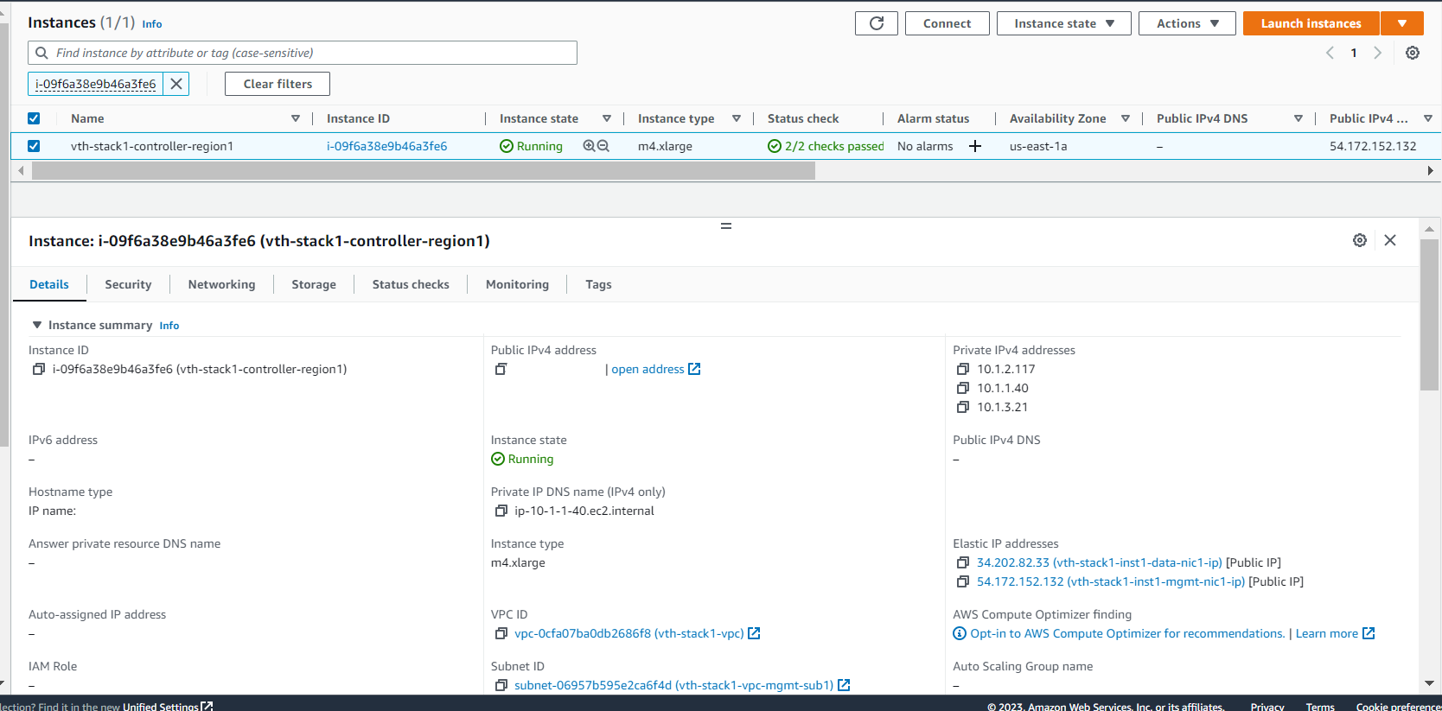

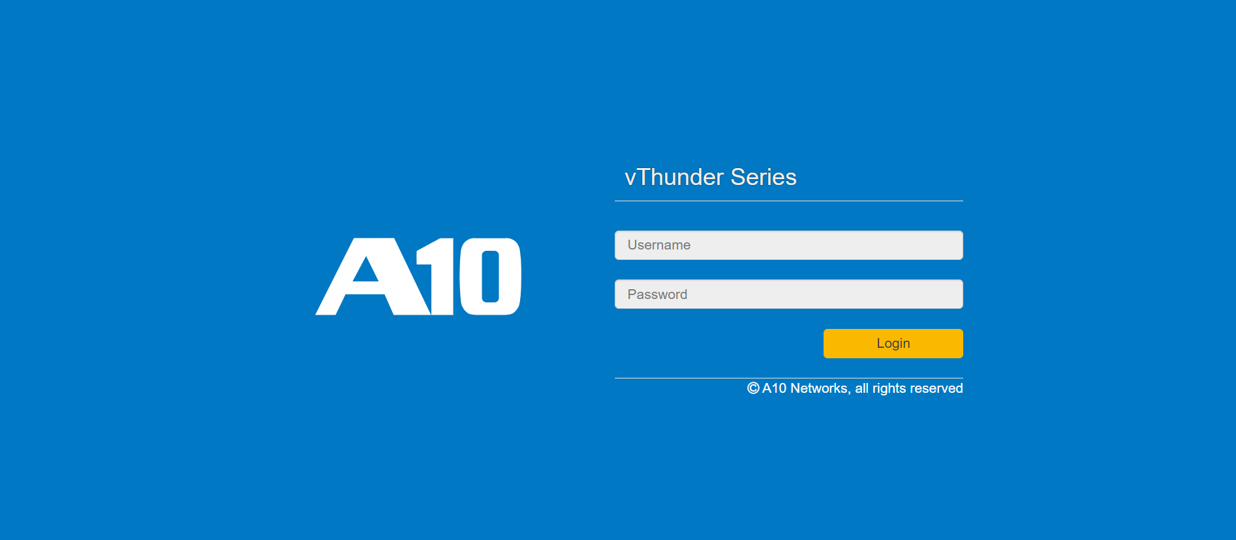

1. Open the stack, check the 3 vThunder created.
2. Region1

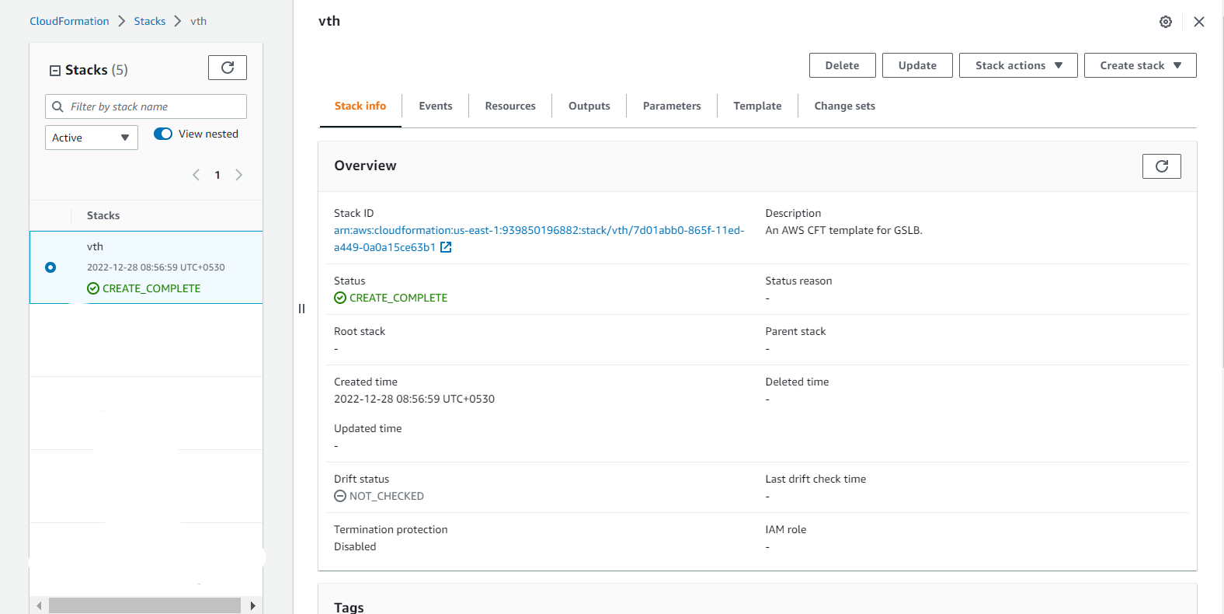

1. Region2

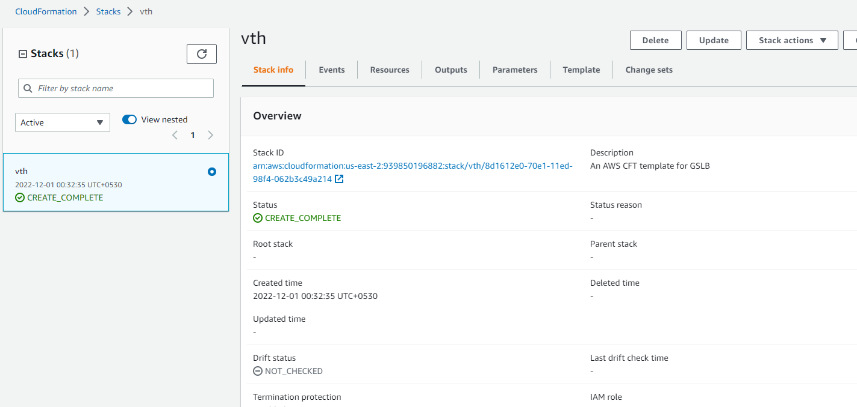

1. Resources are created

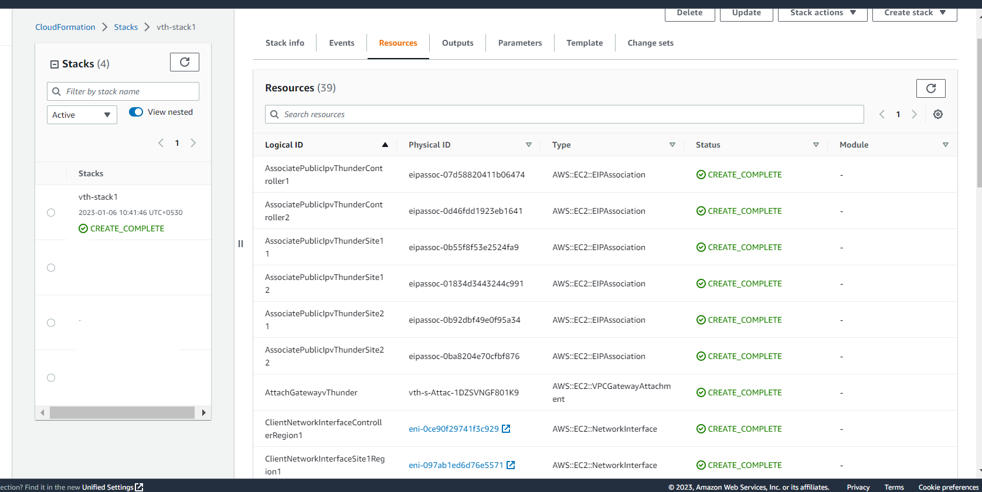

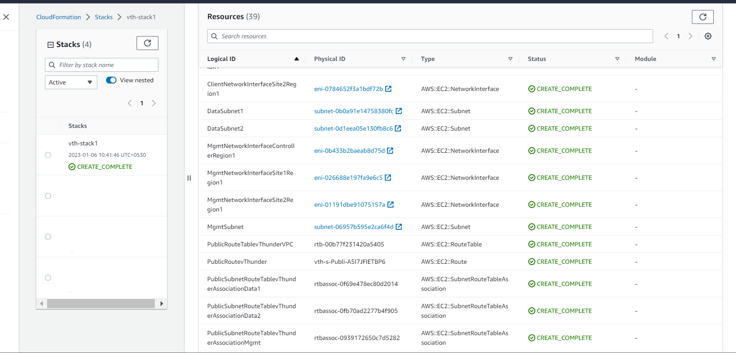 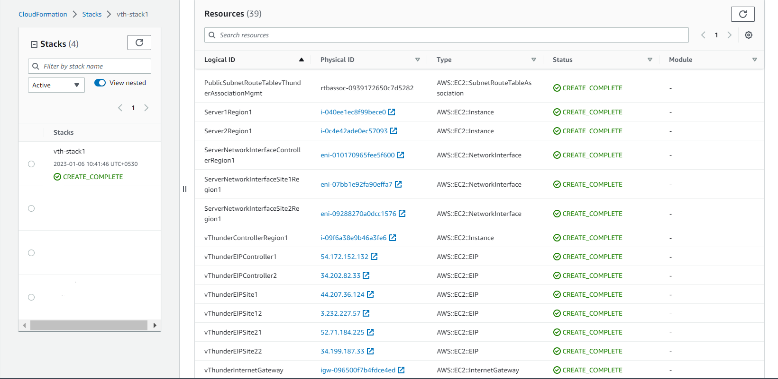

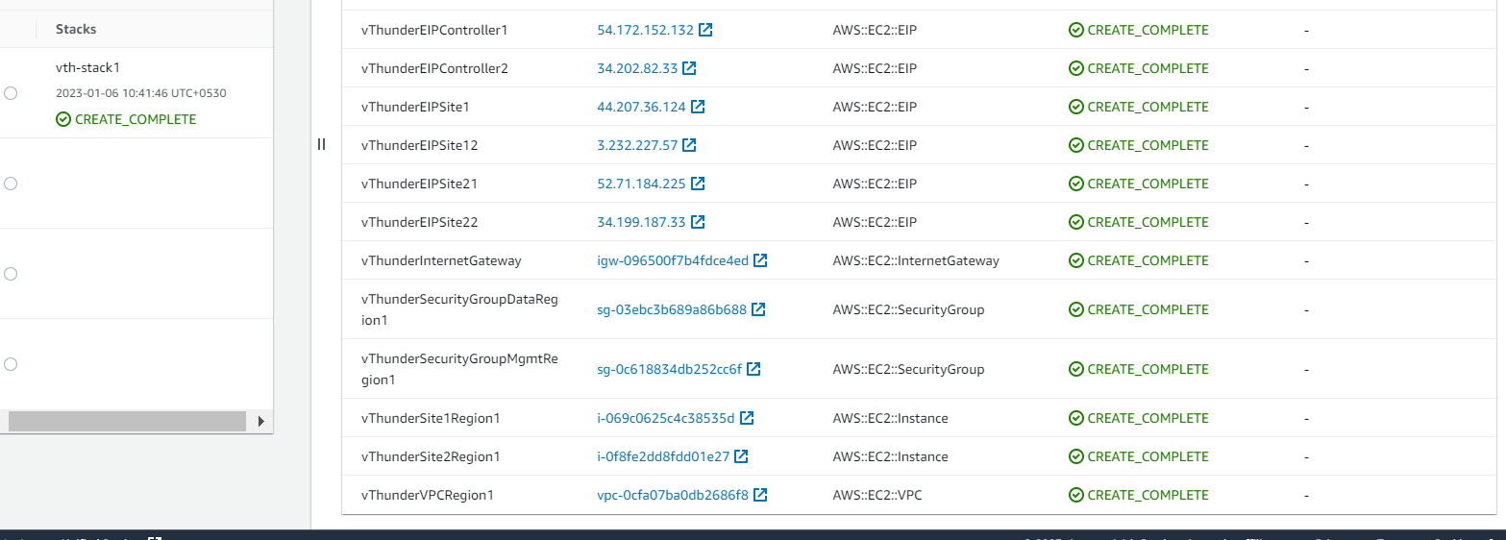

# Chapter 2 - GSLB configuration Setup

### Configure

User can set following configurations in CFT\_TMPL\_3NIC-6VM-2RG-GSLB\_CONFIG\_GSLB\_PARAM.json based on their needs.

1. Add stack name and region of each vThunder as per its GSLB Region.

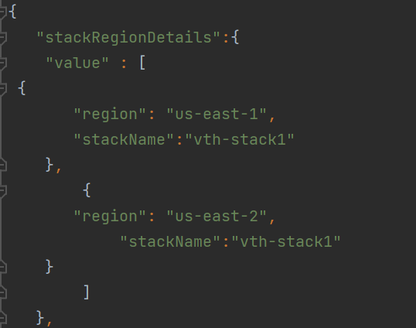

Open your CMD in current working directory.

Run : Python ./CFT\_TMPL\_3NIC-6VM-2RG-GSLB\_CONFIG\_GSLB\_3.py

Provide below configuration params:

### Sites and Controller Complete Configurations:

1. CONTROLLER – region1 CONFIG:

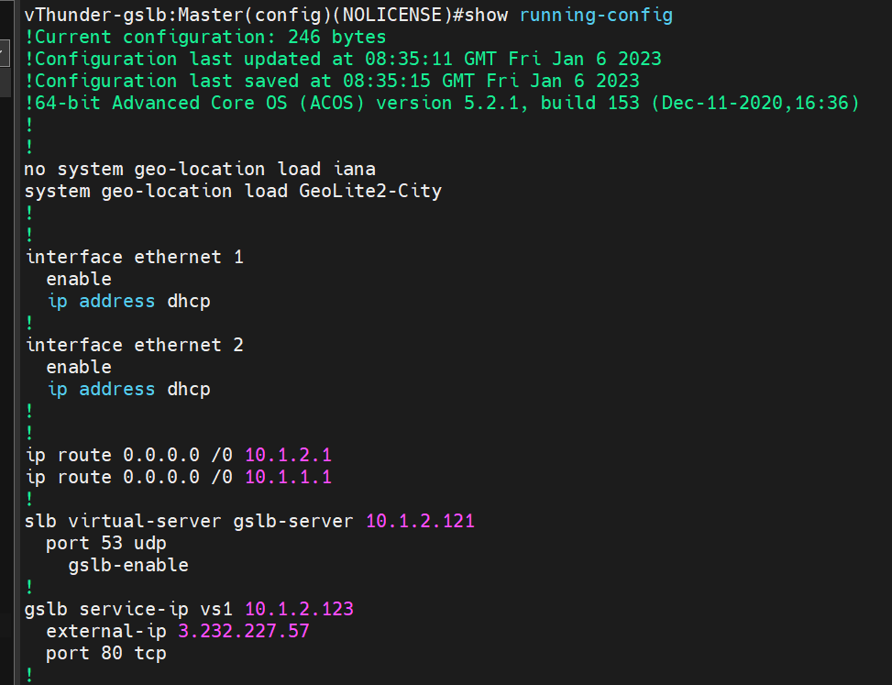

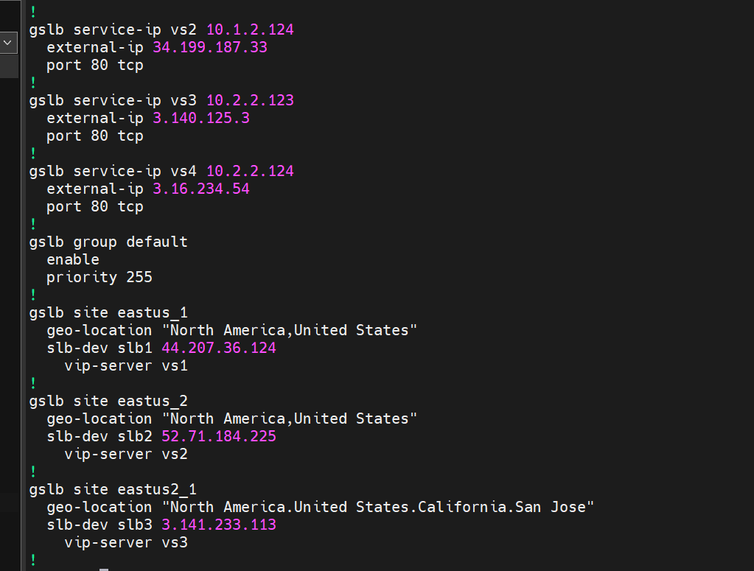

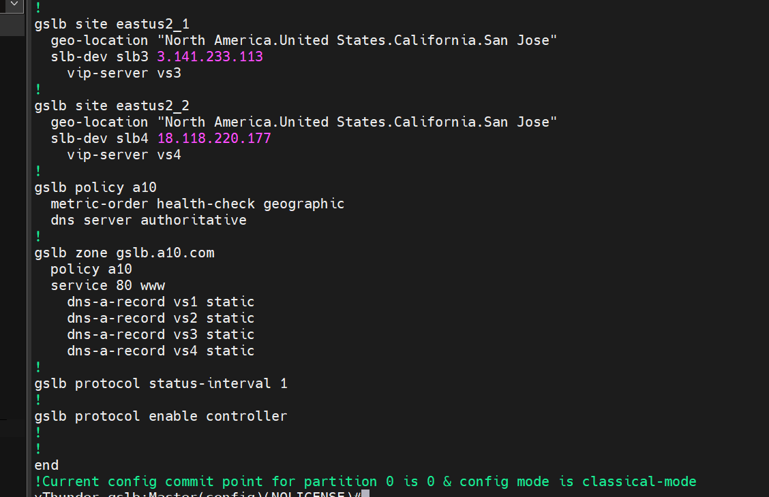

1. CONTROLLER -region2 CONFIG:

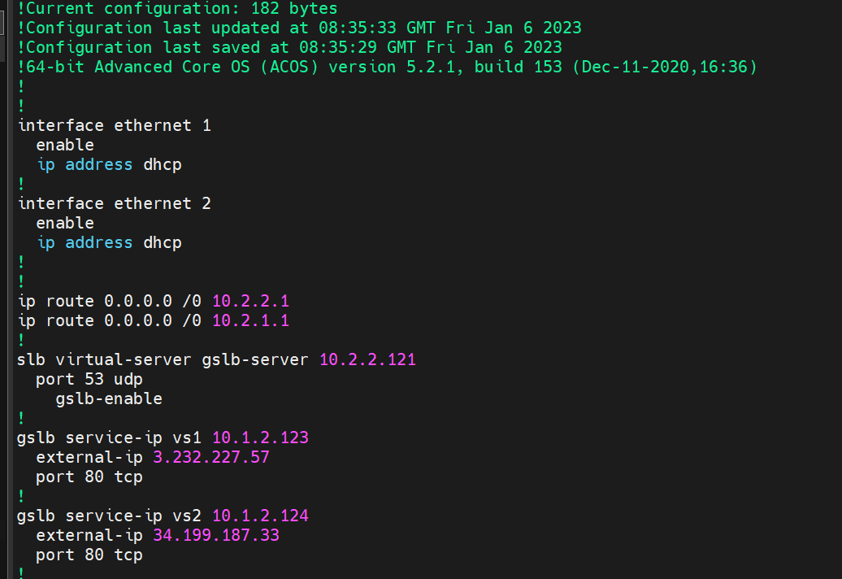

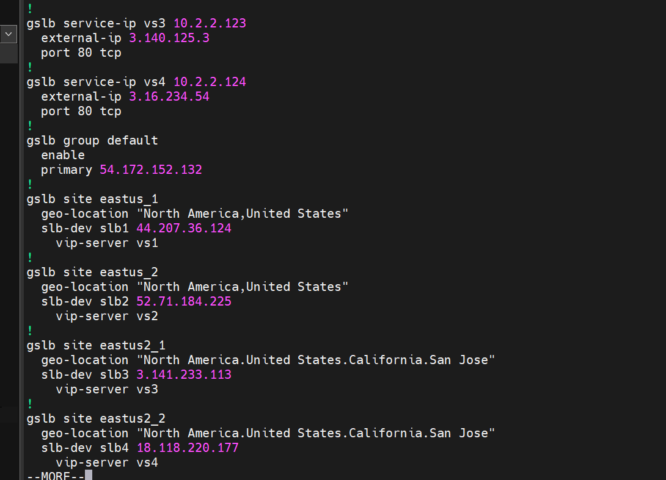

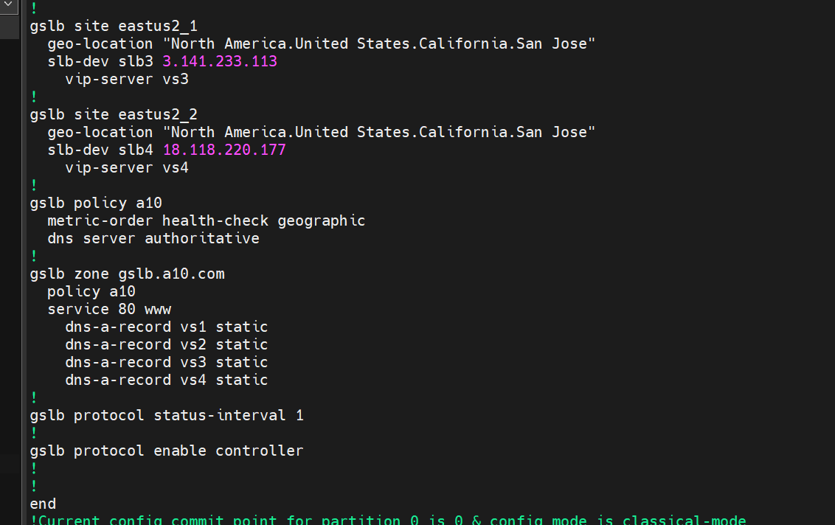

1. SITE 1(region1) configuration:

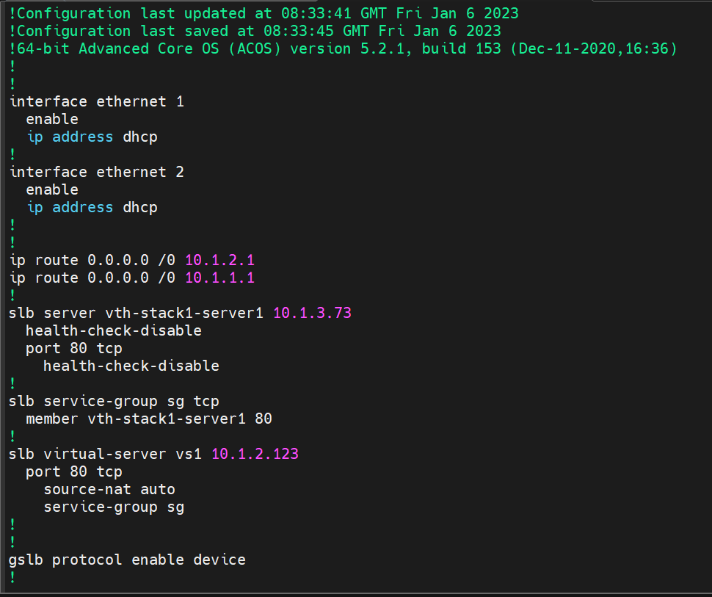

1. SITE 2(region1) configuration:

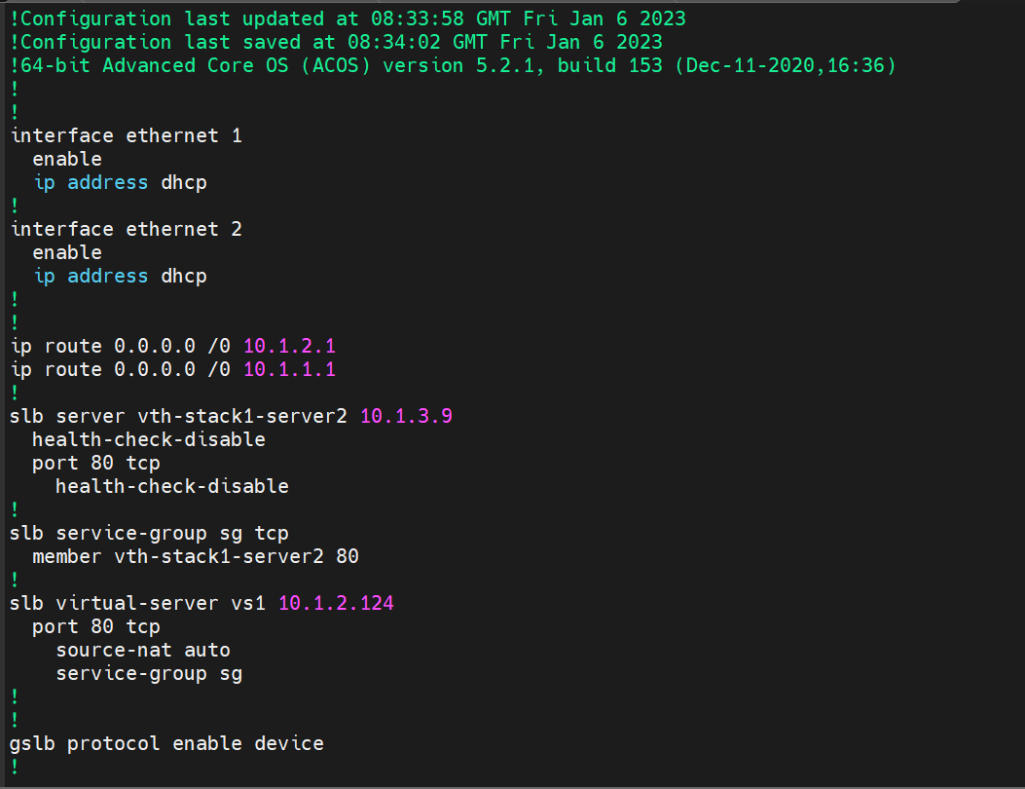

1. SITE 1(region2) configuration:

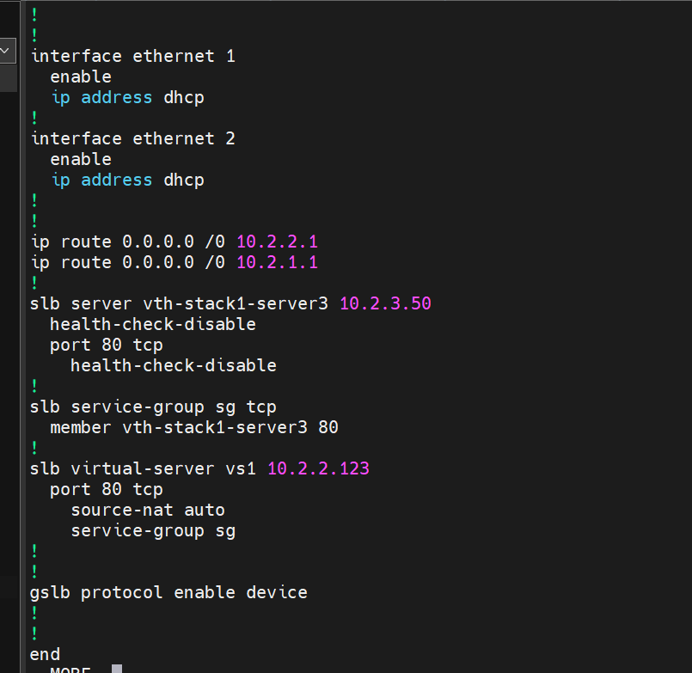

1. SITE 2(region2) configuration:

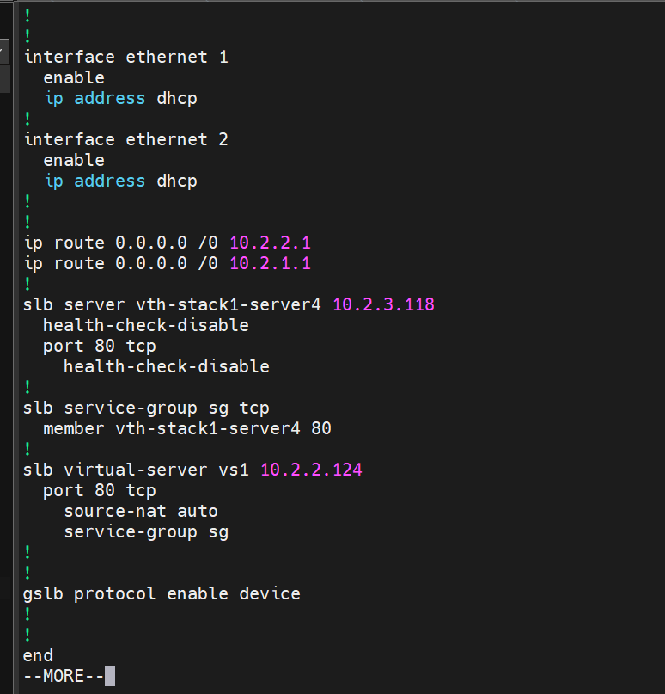

### Verify

Check the GSLB controller and site devices configuration on both regions, make sure they are added correctly.

# 

# Chapter 3 – Let us Verify

### Login to vThunder

vThunder can be access by ssh to instance or GUI.

SSH to vThunder Instance:

Open putty and connect with ssh key.

IP: Get 3vthunders login

User Id [Default]: admin

### GSLB Group

1. Execute following command on each vThunder-Controller

*show gslb group*

1. {stack name} -controller-region1

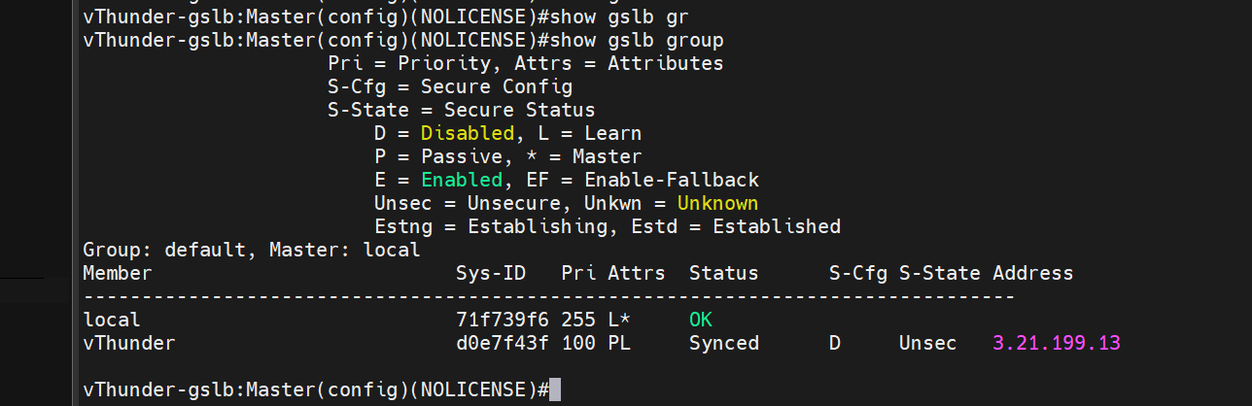

1. {stack name} -controller-region2

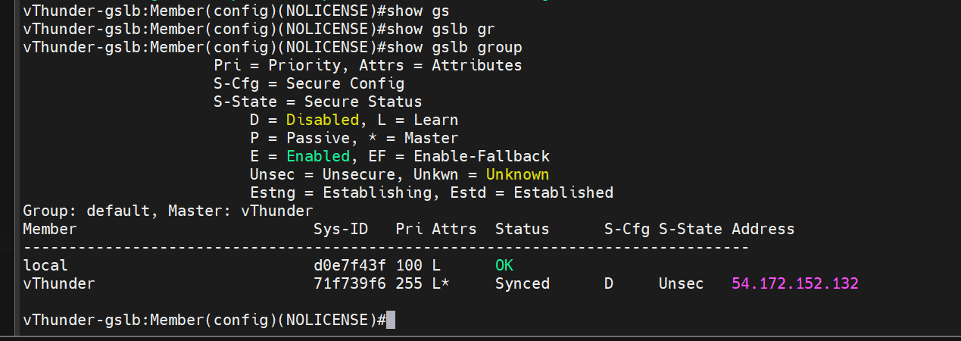

### GSLB Protocol

1. Execute following command on each vThunder-Controller

*show gslb protocol*

1. vth-controller-region1

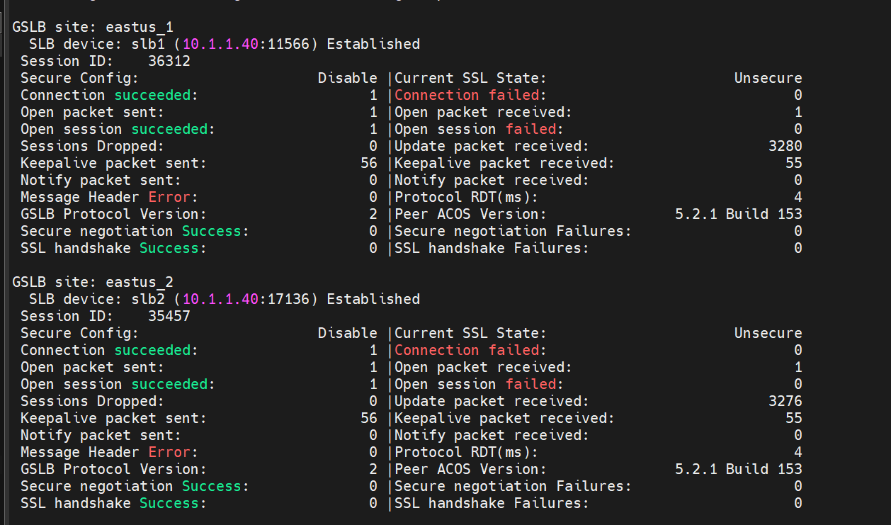

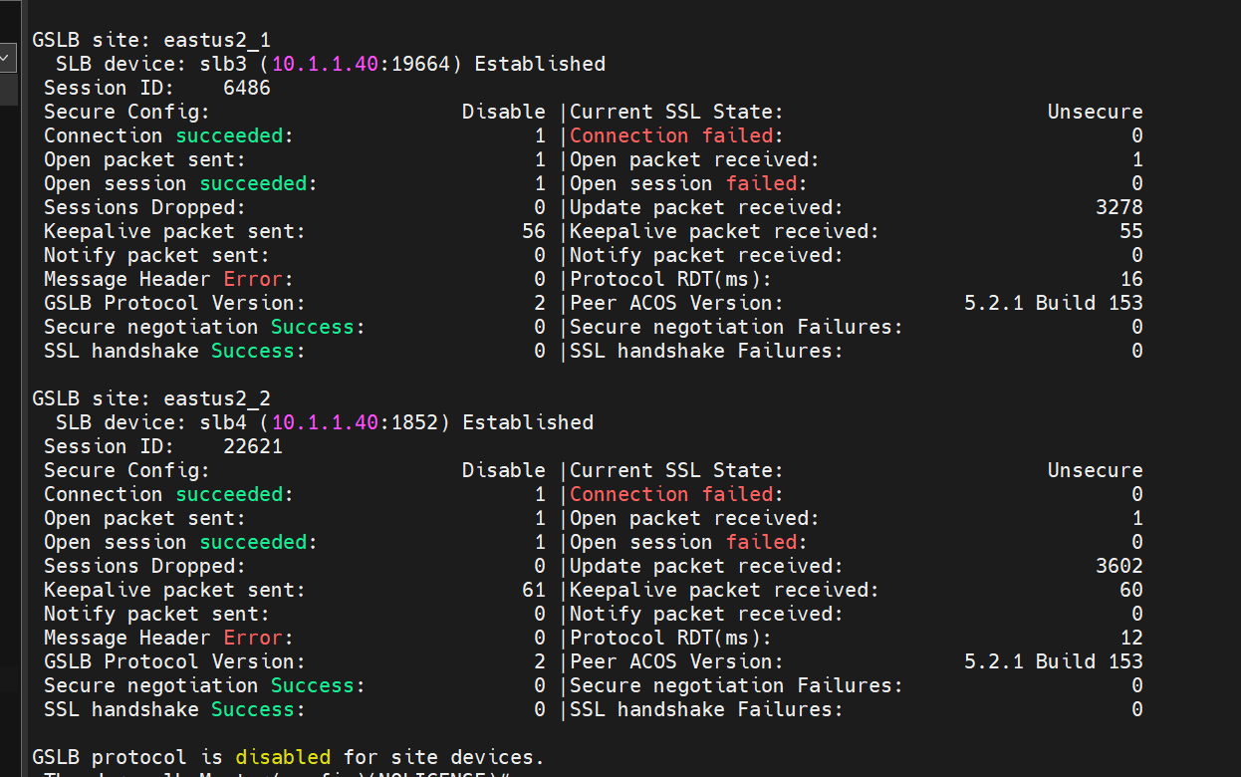

1. vth-controller-region2

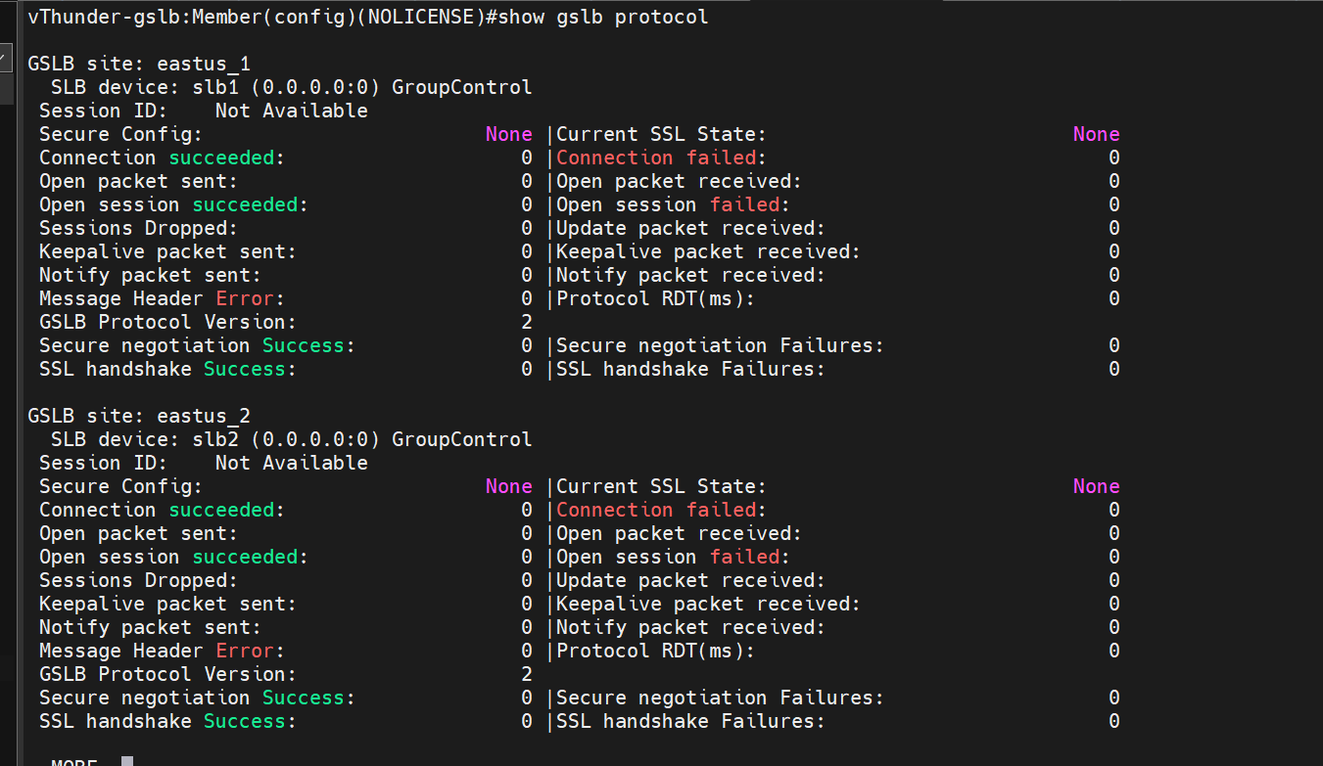

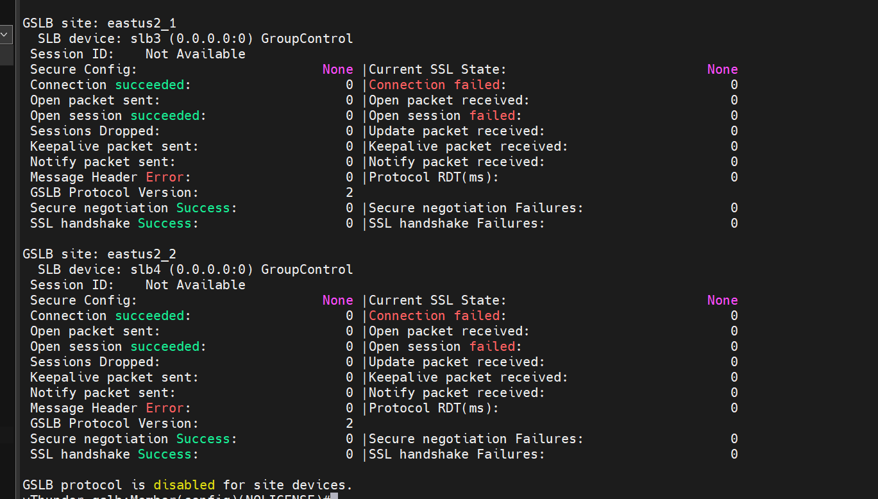

### DNS lookup

Use region1 controller’s public IP of client side data interface as DNS server IP to do DNS lookup.

***$ dig @data-public-IP www.gslb.a10.com***

Path: Instances>> vth-controller-region1>> Networking

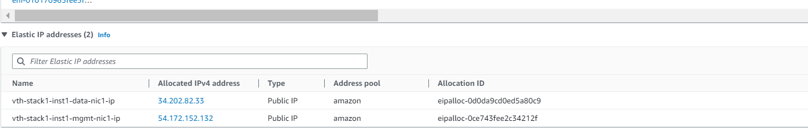

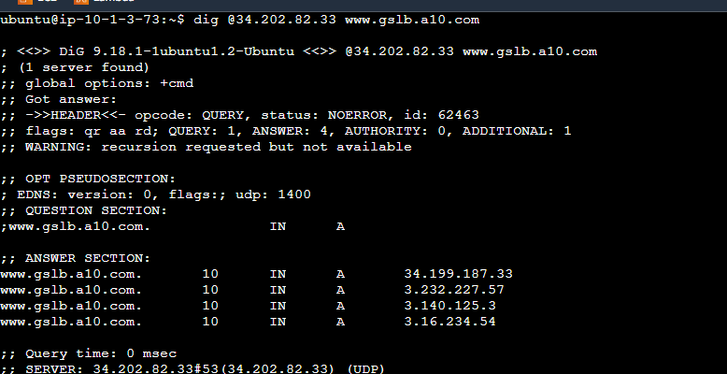

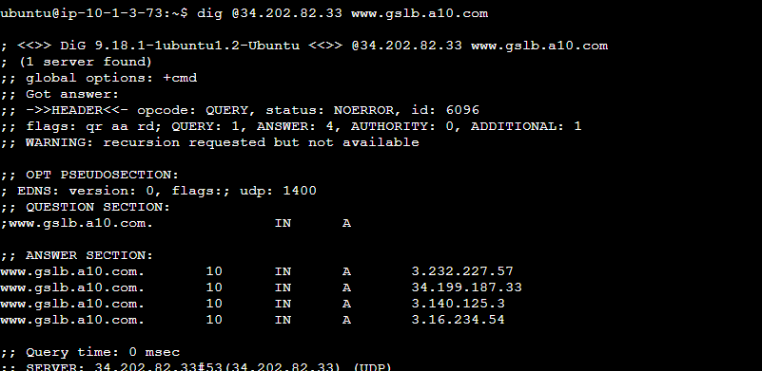

stopping the site instances of region1 and then running the dig command again.

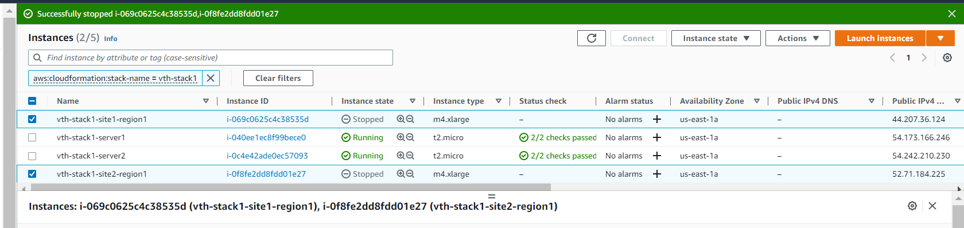

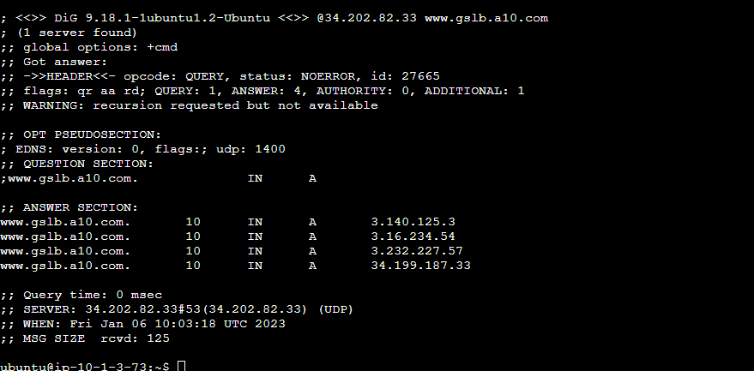

### WGET

1. Install apache on any of the 4 servers using following command.

***$ sudo apt install apache2***

1. Use any region’s site public IP of client side data interface.

Note: use the ip of the corresponding site device on which the apache was installed for e.g use region 1 site 1 ip if the apache is installed on server1.

Path: Instances>> vth-site1-region1>> Networking

***$ wget @data-public-IP***

